**ID REPO VID SERVICE**

VID Service provides functionality to create/update Virtual IDs mapped against an UIN. It also provides the facility to update the status of VID. VIDs are created based on the VID policy defined in the configuration.

**BATCH JOB**

[Batch jobs are typically used for tasks that require minimal human interaction](https://www.bing.com/ck/a?!&&p=9bb145062779f788JmltdHM9MTY5MDE1NjgwMCZpZ3VpZD0xOTJjMDliZS0yZmQ0LTZkNzUtMzkyYS0xYjAyMmUwNjZjY2MmaW5zaWQ9NTczNA&ptn=3&hsh=3&fclid=192c09be-2fd4-6d75-392a-1b022e066ccc&psq=what+is+batch+job&u=a1aHR0cHM6Ly93d3cuaWJtLmNvbS9kb2NzL2VuL2kvNy4zP3RvcGljPXR5cGVzLWJhdGNoLWpvYnM&ntb=1) [such as generating reports or processing large files](https://www.bing.com/ck/a?!&&p=9bb145062779f788JmltdHM9MTY5MDE1NjgwMCZpZ3VpZD0xOTJjMDliZS0yZmQ0LTZkNzUtMzkyYS0xYjAyMmUwNjZjY2MmaW5zaWQ9NTczNA&ptn=3&hsh=3&fclid=192c09be-2fd4-6d75-392a-1b022e066ccc&psq=what+is+batch+job&u=a1aHR0cHM6Ly93d3cuaWJtLmNvbS9kb2NzL2VuL2kvNy4zP3RvcGljPXR5cGVzLWJhdGNoLWpvYnM&ntb=1).

We added query to run the batch job for temporary vid and it will take the current date and expire date.

Expiry date will be configure, it will run the specific configuration time (midnight 12:00AM)

After running the batch job will get the notification for the email and mobile number

**Response in Notification:**

Generating VID

karthik@gmail.com          Acknowledgement: Generate VID|event ID: 1938929181768766|Status:success Date:7/21/2023, 7:19:15 PM        From: [do-not-reply@mosip.io](mailto:do-not-reply@mosip.io)

Dear karthik, <br> Your request to Generate VID is completed successfully on 21-07-2023 at 06:59:06. <br> Your event id is #1938929181768766. <br> Log in to the official website <https://resident.tfgov.idencode.link/#/uinservices/trackservicerequest?eid=1938929181768766> for further details.

For Expiry Vid

[karthik@gmail.com](mailto:karthik@gmail.com) Vid Getting expired Date:7/21/2023, 12:50:10 PM From: [do-not- reply@mosip.io](mailto:do-not-%20reply@mosip.io)

Hi karthik, Your Vid:4*************89 is going to expire by 2023-07-22. Thank You!

This Expired vids will store in idmap.vid_expirylist table, here we can check the status of Id, Vid, Created-date, Is_smssend, Is_emailsend(True) (Note:- expired vid(value) will deleted after 24 hours)

In case of server issue, if notification is not send. In this table the status of Is_smssend and Is_emailsend is false. batch job will run again and the status will change in the table. In Notification service it will call the Audit

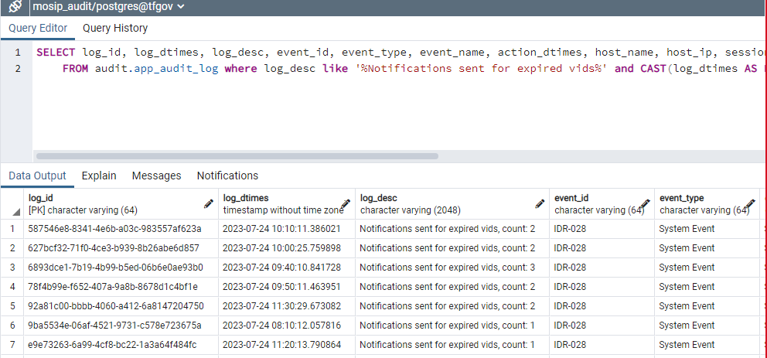

In audit.app_audit_log we will get the count of vids how many Temporary vids we created it will display in **Log_desc** column